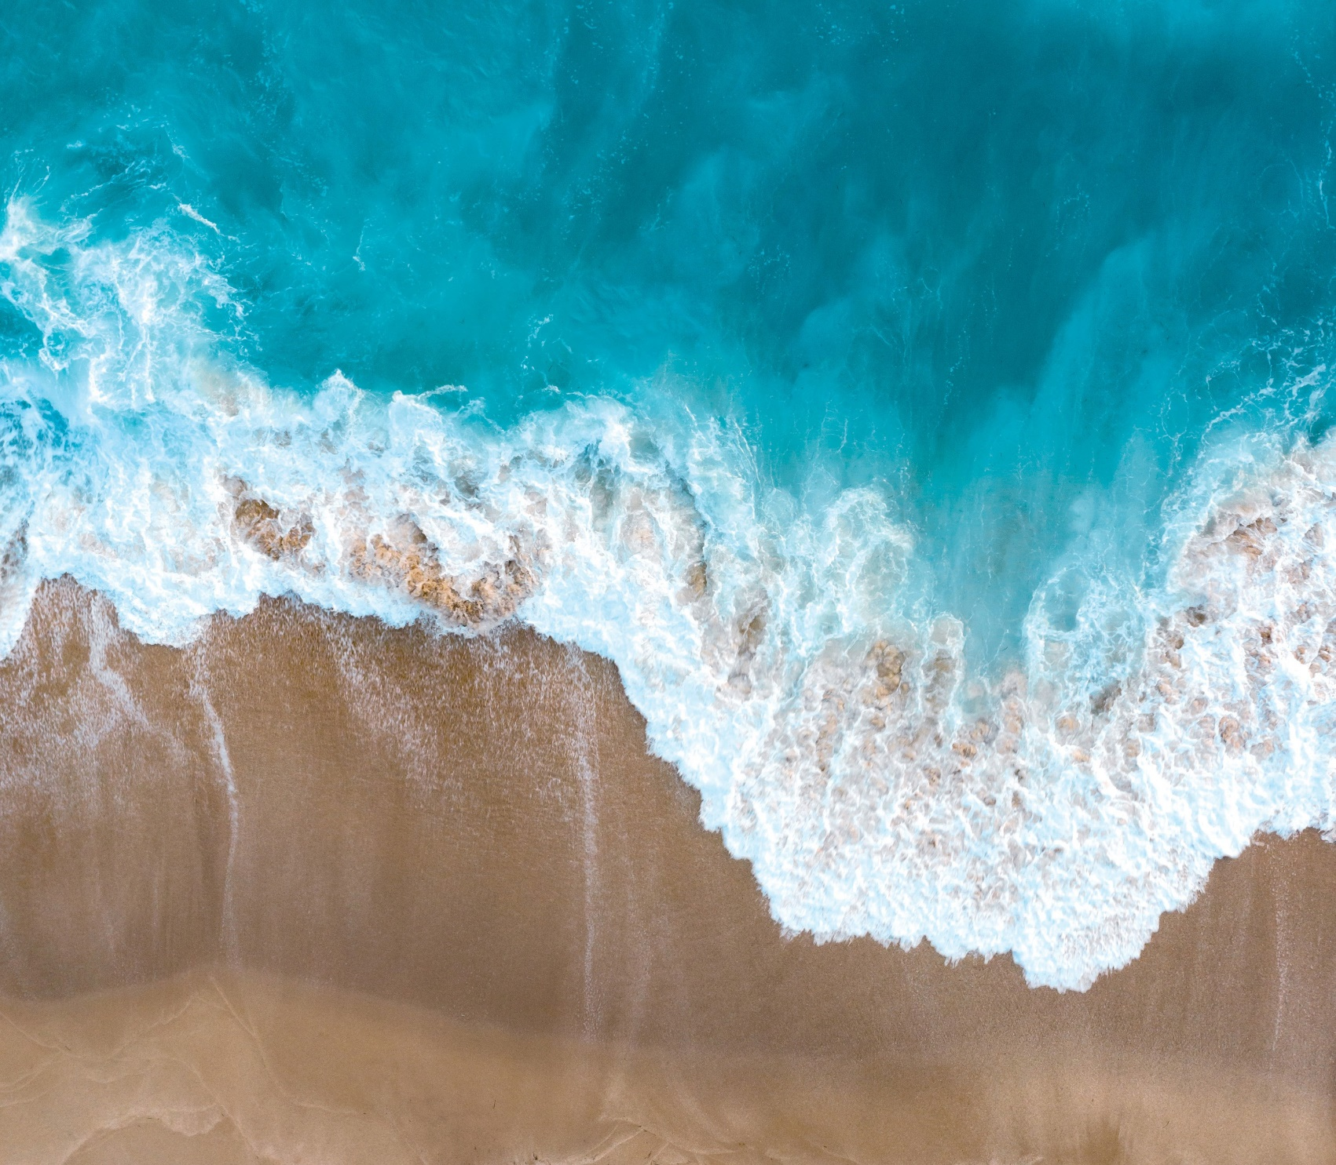
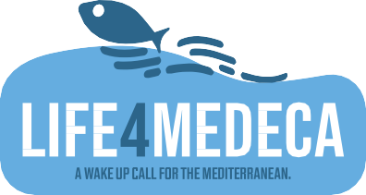
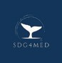

FINAL CONFERENCE
GREEN TRANSITION FROM THE MED TO OCEANS AND SEAS
18th OCTOBER 2023 LIVORNO
VILLA HENDERSON
MUSEO DI STORIA NATURALE DEL MEDITERRANEO

9.00 - 10.00: Registration & Welcome coffee

10.00 - 11.00: Welcome and Introduction

Welcome Luciano Guerrieri
President of the Northern Tyrrhenian Port Network Authority (AdSP-MTS)

Introduction Francescalberto De Bari, AdSP-MTS - LIFE4MEDECA Coordinator
VIDEO “A WAKE UP CALL FOR MEDITERRANEAN”
The relevance of LIFE4MEDECA for maritime policy - LIFE4MEDECA Advisory Board Members:
Samy Djavidnia European Maritime Safety Agency (EMSA) (tbc) Margot Parcaroli Ruiz Secrétariat d’État chargé de la Mer (FRANCE) The importance of PLP project for enviromental policy
Santiago Urquijo Zamora
EU Commission DG ENV - LIFE4MEDECA Project Officer

11.00 – 12.45: 1st Panel
“Accomplishments and legacy of the LIFE4MEDECA initiative” Moderator: Giampiero Costagli

Marco Campomenosi (Member of EU Parliament) Current and future Med challenges
Mario Dogliani (3D4EU - LIFE4MEDECA Tech Manager) Triggering a greener Med through LIFE4MEDECA
Kare Press (Green Transition Denmark) Measuring the ECAs: Baltic vs Med, SECA vs NECA
VIDEO “THE LIFE4MEDECA PROJECT”
Elena Ciappi, Elena Paifelman (CNR-INM) / Manuela Scarsi (AdSP-MTS) Knowledge Center: the LIFE4MEDECA heritage
Salvatore Quinci (Municipality of Mazara del Vallo, FLAG Trapanese) LIFE4MEDECA stakeholders’ comments
Paolo Dario (ARTES 5.0): Assessment of technologies and innovative solutions

12:45 – 14:30: Networking lunch

14.30 - 16.00: 2nd Panel

“Greening the Med: from LIFE4MEDECA to MISSION OCEAN”. Moderator: Mario Dogliani

VIDEO “WILL YOU SAVE ME?”
Claudia Pecoraro (EU Commission EC DG RTD) Mission Ocean objectives and way forward
Giuseppe Coronella (Fincantieri) – Greening by technology (tbc)
Francesca Corso / Stefania Manca (Municipality of Genova) Greening by sharing: the coalition of Mayors
Angela Di Febbraro (University of Genova) – Greening by teaching
Gianluca Dini (University of Pisa – Center for Logistic Systems) Greening by researching
Manuel Picardi (European School Driver Association - EFA) Greening by imitation
Francesco Beltrame (ENR): Green-Blue Tech the way foward

16.00 – 17.30: 3rd Panel
“Cooperating for the Green Transition at Sea: from ports to the oceans” Moderator: Francescalberto De Bari

Leonardo Manzari (WESTMED Initiative)
Leaving no one behind: the cooperation in the Med
Fedra Francocci (Blue Mission Med) – Mission Ocean’s Med Lighthouse
Raphael Lobeto Lobo (Fundaciò Philippe Cousteau)
Challenges and opportunities: towards a Mediterranean Transition
Roundtable “The Green Transition from ports to the world”:
Suzan kholeif - SDG4MED Director for Africa
Reda Ismail - Maritime Transport Sector - Ministry of Transport (Egypt)
Mohi-Eldin M.Elsayeh - College of Maritime Transport and Tecnology (Egypt)
Nahid Shaheen Ali Shaheen - Alexandria Port Authority (Egypt)
Foued Othman - Office de la Marine Marchande et des Ports (Tunisia) (tbc) Nadia Laraki - Agence Nationale des Ports (Maroc) (tbc)
Garip Çavuş Findik - Regional Port Authority of Instanbul (Turkey)
Representative - Coast Guard Command (Turkey)
Boumedienne Beladjine – University of Oran (Algeria)
Massimo di Marco – Italian Coast Guard – International Affairs (Italy)

17.30 – 18.00: Conclusions

Closure Matteo Paroli, Secretary General AdSP-MTS
AdSP MTS Official Signature of the Charter for the EU Mission “Restore our ocean and waters by 2030”

COORDINATOR

PROJECT PARTNERS

This project is funded under the LIFE programme, the EU’s funding instrument for the environment and climate action (Grant Agreement LIFE20 PRE/IT/000002).

